Key Technical Skills & Knowledge  - Salesforce.com (Configuration, Customization, Integration)  - Lightning  - Configuration (sObject, Relationship, Page Layout, Workflow Rules, Approval Process, Validation Rules, Custom Settings etc.)  - Force.com (Apex, Visual Force, Triggers, Batch jobs, Schedulers)  - Data Migration Tools (Data Loader, Import Wizard, Work Bench)  - Security  - Integration with Third Party Web Services (Rest And SOAP API)  - Reports and Dash Boards |  | 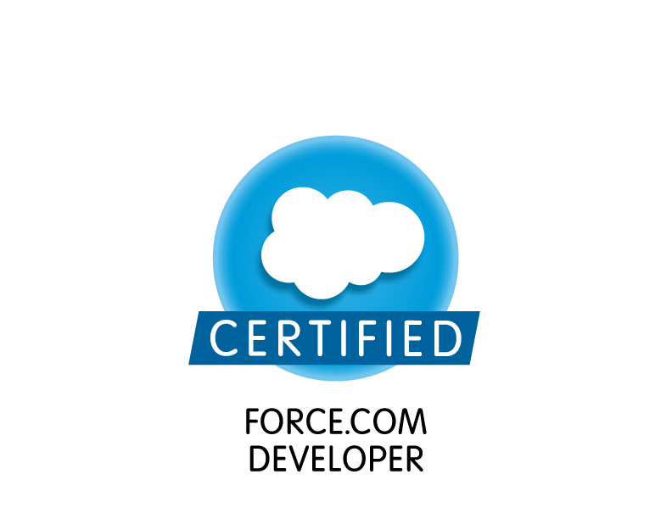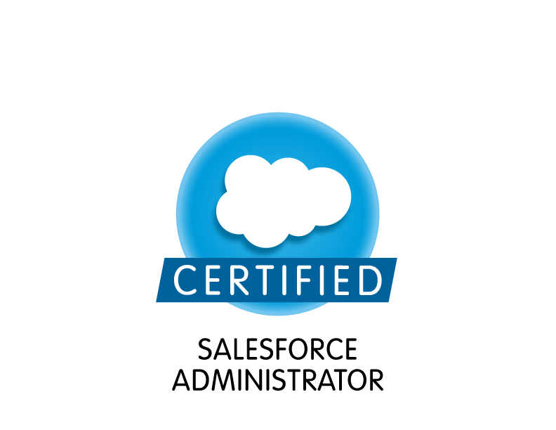  Profile Summary  - A driven IT professional with 5 Years of solid experience in Java development (1 years) and Salesforce (4 years).  - Having a good knowledge on Salesforce.com (SaaS) Configuration, Apex, Visual force Pages.  - Hands on experience of Lightning components and applications.  - Hands on working knowledge of Data loader and Import Wizard for Data Migration.  - Having a working experience on web development technologies (JSP, Servlet, Struts2, Hibernate and spring).  - Having a good knowledge on Database Query Language likes SQL, PL/SQL and SOQL.  - Efficient in all the phases of Development Lifecycle of the project such as gathering business requirements, analysis, design, execution and documentation.  Training and Certifications  - Completed INFOSYS 6 months training at Mysore in C,C++,C#,JAVA,RDBMS  (Specialization in Dot Net).  - Completed CCP - Cognizant’s internal certification on SFDC Configuration and Customization.  - Salesforce Certification - Salesforce.com Certified Force.com Developer -(DEV 401)  - Salesforce Certification - Salesforce Certified Administrator-(ADM 201)  - Microsoft Certification - Programming in HTML5 with JavaScript and CSS3.  - Microsoft Certification - Programming in C#.  Projects Undertaken :  1.Cognizant Technology Solutions Limited:  Associate Projects Oct 2014 – till date  Title : SMS Engine  Role : Development  Platform : Salesforce Configuration/Apex/Visual force  Client : Abbott  Team Strength : 2  Objective:  SMS engine will be sending timely SMSes to TBMs, ABMs and ZBMs (Users) about the hygiene parameters and will help them not miss on important parameters and incentives. This will be a tool to motivate employees to chase targets or brands and a timely help to not let them miss out on their gains due to some key parameters.  Responsibilities:  - Creating objects, custom fields, Workflow Rules and Validation Rules etc.  - Writing triggers, Apex classes, Test classes and VF pages.  - Writing Scheduler classes  - Involved integration with NETCORE to send SMSes (Rest API).  - Involved in deployment using Change sets.  - Bug fixing during all phases of testing like Functional Testing, System integration Testing and User Acceptance Testing.  Title : ETender  Role : Development  Platform : Salesforce Configuration/Apex/Visual force  Client : Abbott  Team Strength : 3  Objective:  ETender is tender Management process simplified in salesforce. In this process, Tender is filled by user and it would be approved by different level of approvers. Approvers are defined based on Hierarchy which is saved in Custom settings.  Responsibilities:  - Creating objects, custom and formula fields, Relationships, Page Layout, Workflow Rules, Custom Approval Process, Custom Settings, Validation Rules etc.  - Writing triggers, Apex classes, Test classes and VF pages.  - Worked on Data loader and import wizard  - Worked Paginations, View State and Query optimizations.  - Used JavaScript, JQuery and Angular Js.  - Involved in deployment using Change sets.  - Bug fixing during all phases of testing like Functional Testing, System integration Testing and User Acceptance Testing.  Title : Asset and Organization management  Role : Development  Platform : Lightning/Apex/Visual force  Client : Honeywell  Team Strength : 6  Objective:  The scope of work was to design and develop an application for End User License Management. The objective of this POC was to get end users of Honeywell’s products into SFDC system. In the present scenario, most of the Honeywell’s businesses operate on a B2B model. So they only know the partners which includes OEMs (Original Equipment Manufacturer), System Integrators, distributors. This project enables the business to know who their end customers are, as well as who is who (who is SI, who is OEM, who is distributor etc.).  As part of the POC we created Lightning Community pages using Lightning components.  Responsibilities:  - Creating Lightning components and application.  - Creating objects, custom fields, Workflow Rules etc.  - Writing triggers, Apex classes, Test classes and VF pages.  - Bug fixing during all phases of testing like Functional Testing and User Acceptance Testing.  Title : DCR  Role : Development  Platform : Salesforce Configuration/Apex/Visual force  Client : Abbott  Team Strength : 3  Objective:  'Daily Call Reports' functionality is provided for the Field Force to capture Feedback, Commitment, Competitor information and the Starter pack drop information at the end of day entry for pharmaceutical client  Achievements:  Awarded by Associate of quarter Award in the project year 2015  Responsibilities:  - Creating objects, custom and formula fields, Relationships, Page Layout, Workflow Rules, Approval Process and Validation Rules etc.  - Writing triggers, Apex classes, Test classes and VF pages.  - Working on Data loader and import wizard  - Involved in deployment using Change sets.  - Bug fixing during all phases of testing like Functional Testing, System integration Testing and User Acceptance Testing.  2.Infosys Limited:  Senior System Engineer Feb 2012 – Oct 2014  Title : ConnectMe-Anywhere  Role : Development  Platform : Salesforce Configuration/Apex/Visual force  Client : Offshore  Team Strength : 5  Objective:  ConnectMe-Anywhere is CRM cloud application which has used basic functionality of ConnectMe. In ConnectMe-Anywhere, Airport agents help customers for enquiry, booking, check-in and boarding procedure. In booking, customer gets created in salesforce as account, contact and opportunity for Flight and hotel service. Customer provides PNR and identity details to agent to receive Boarding pass. Since there are multiple agents with multiple departments with business role hierarchy. Agent will check and send PNR as well as customer details to Higher authority for further approval. After validating PNR and customer details, Agents will help customer for their boarding procedure. Agents communicate with higher authority regarding discounts and promotional services also.  Achievements:  Awarded by BRAVO AWARD for excellent performer in the project year 2013  Responsibilities:  - Migration of Agent module to Sales cloud in Salesforce  - Mapping existing functionality/process to cloud application in Salesforce  - Creating objects, custom fields, formula fields, validation rules, Workflow rules etc.  - Writing triggers, Apex classes, Test classes and VF pages.  - Worked on web services to fetch the customer details from Customer Masters  - Understand functional requirements and development as per requirement.  - Involved in deployment using Change sets.  - Bug fixing during all phases of testing like Functional Testing, System integration Testing and User Acceptance Testing.  Title : ConnectMe  Role : Development and support  Platform : Java and J2EE  Client : American Airlines  Team Strength : 10  Objective:  ConnectMe is CRM application used to provide intercommunication between airport agents regarding customer support. This application notify agent to send and receive messages based on their role and the user id. It defines the agent roles as tree templates for each airport station based on hierarchy. The application has 2 parts based on the user group. One that runs on handheld device and constantly communicates with the server to send and receive messages. Other is an Admin tool (web application), that allows creation and modification of role templates for each station.  Responsibilities:  - Eclipse IDE and Visual Studio 2008 IDE for development  - Oracle TOAD and SQL developer for running the query scripts  - Xfire framework for generating SOAP Web Service  - Build and Deployment of EAR using IBM WebSphere and Apache Tomcat  - Winscp and Putty for monitoring the logs  - Documentation Development and Unit Testing using Junit and Nunit  - Microsoft Visual Source and Tortoise SVN for storing the codebase and documents  Personal Details:  - Date of Birth : 16 October 1989  - Marital Status : Unmarried  - Language Proficiency: English, Marathi, Hindi  - Address: 21-1646, Kripasiddhi CHS, Old MHB colony, Borivali(West),Mumbai-400091  - Nationality: Indian  - Passport Details: Passport No.J1698151 Date of Expiry:18/08/2020
  Academics
  B.E (Bachelor of Engineering) from Atharva College of Engineering , Mumbai University.
  Qualification | Subject | College/School | Percentage
  Bachelor Of Engineering | IT Engineering | Atharva College of Engineering, Mumbai | 61.90
  Standard XII/ H.S.C. | Others | Thakur, Mumbai | 84.67
  Standard X/ SSC | Others | Suvidyalaya, Mumbai | 83.86
  Skill Set
  Dkjk
  Cloud Platform | Salesforce.com(SaaS), Force.com(PaaS)
  Salesforce Tools | Data loader, Soap UI, Postman, Selenium
  Languages | Apex, Visual force, Java, C#,C++,C
  Frameworks And Architectures | Java: JDBC, Web Services, Struts2,Spring,JSF,EJB and Hibernate  Dot Net: ADO.net, Windows Forms Applicaton,ASP.net, ASP MVC Application, Entity Framework
  Web Technologies | HTML, Servlets, JSP, AJAX, Angular JS, JavaScript, XML and CSS
  Databases | Oracle 10G, SQL Server 2005
  Tools & IDE | Eclipse, Tortoise SVN, Net Beans and Microsoft Visual Studio
  Operating Systems | Windows 7/ Vista/ XP Professional

